MAGNUM EMPLOYMENT SVCS PTE LTD (17C8840)

BIO-DATA OF FOREIGN DOMESTIC WORKER (FDW)
*Please ensure that you run through the information within the Biodata as it is an important document to help you select a suitable FDW
(A) PROFILE OF FDW
A1 Personal Information
1. Name:PIPIT
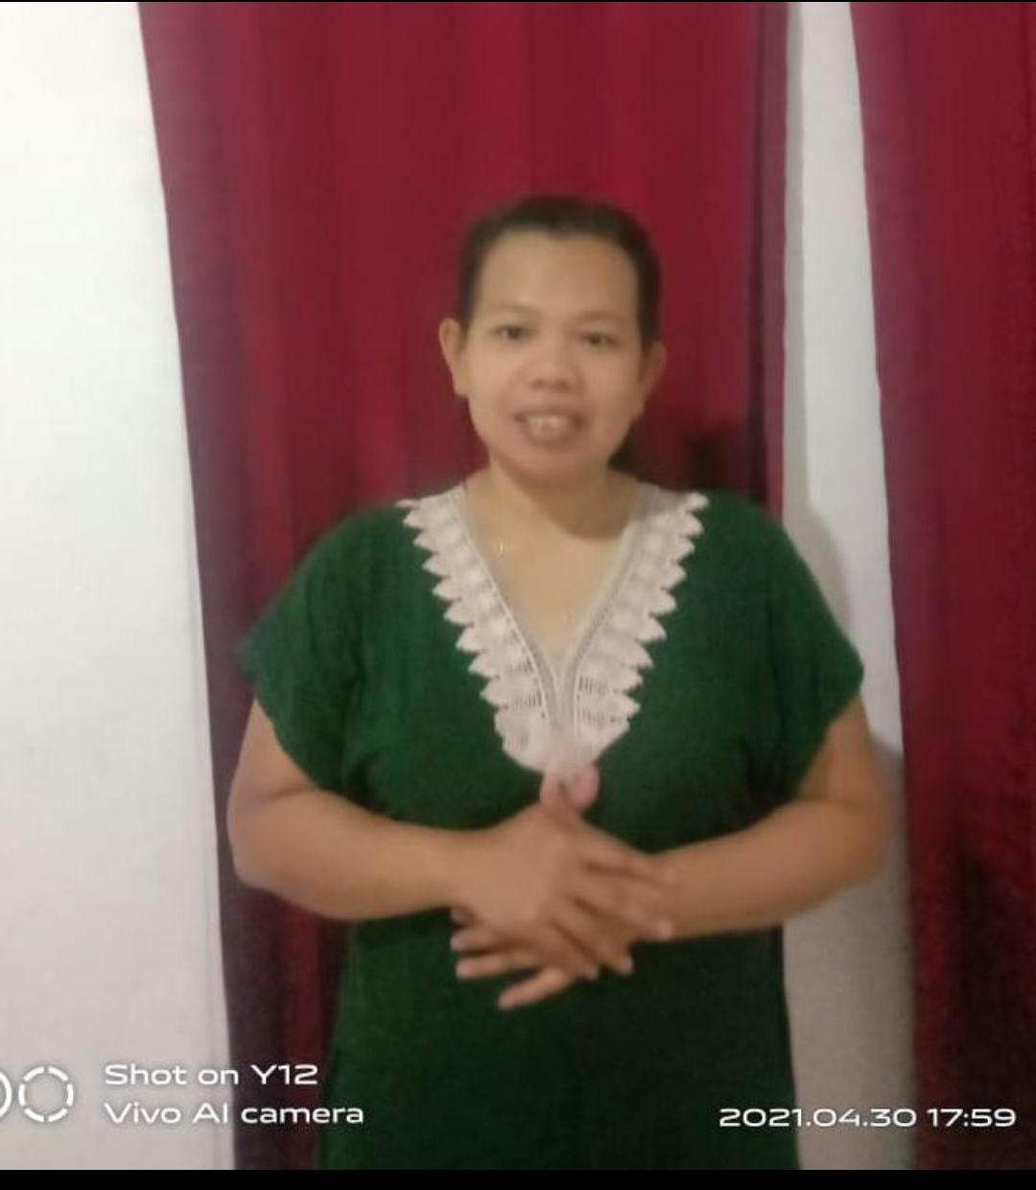
2. Date of birth:19 Jun 1984 age:37
3. Place of birth: Serang Banten
4. Height & weight:156cm &60kg
5. Nationality: Indonesia
6. Residential address in home country: Wonosobo Central Of java
7. Name of port / airport to be repatriated to:Ahmad Yani Semarang
8.Contact number in home country: +628561140892
9. Religion: Muslim
10. Education level: Secondary school
11. Number of siblings: 3
12. Marital status: Married
13. Number of children: 1 Daughter
- Age(s) of children (if any):11Years Old
- Passport Status: Aktif
A2 Medical History/Dietary Restrictions
14. Allergies (if any): NIL
15. Past and existing illnesses (including chronic ailments and illnesses requiring medication):
Yes No Yes No
i. Mental illness vi. Tuberculosis
ii. Epilepsy vii. Heart disease
iii. Asthma viii. Malaria
iv. Diabetes ix. Operations
v. Hypertension x. Others:
16. Physical disabilities: Nil
17. Dietary restrictions: Nil
18. Food handling preferences: No pork No beef others:

A-1
A3 Others
19. Preference for rest day: $650 (4) rest day(s) per month.
20. Any other remarks:
(B) SKILLS OF FDW
B1 Method of Evaluation of Skills
Please indicate the method(s) used to evaluate the FDW’s skills (can tick more than one):
- Based on FDW’s declaration, no evaluation/observation by Singapore EA or overseas training center
- /EA
- Interviewed by Singapore EA
- Interviewed via telephone/teleconference
- Interviewed via videoconference
- Interviewed in person
- Interviewed in person and also made observation of FDW in the areas of work listed in table
S/No | Areas of Work | Willingness  Yes/No | Experience  Yes/No  If yes, state  the no. of  years | Assessment/Observation  Please state qualitative observations of FDW and/or rate the  FDW (indicate N.A. of no evaluation was done)  Poor ……………………Excellent...N.A  1 2 3 4 5 N.A
1. | Care of infants/children  Please specify age range: | YES | Yes | Yes, Experienced in caring newborn to Preteens. Changing diapers, changing clothes, feeding (night feeds), bathing, Send/fetch children to school
2. | Care of elderly | YES | Yes,3years | Experienced in caring for elderly, transferring from wheelchair to commode, bed, vehicles. Dispensing of medication, medical appointments, Exercise therapy etc
3. | Care of disabled | YES | NA | Don’t have experience but will to learn
4. | General housework | YES | Yes,3years | General household chores,cleaning washing,laundry,ironing,sweeping vacuum,mopping,groceries/marketing.etc
5. | Cooking  Please specify cuisines: | YES | YES | Indonesia food:rendang cap cay,cury chicken,fried rice fried behoon fried vegetable.etc Chinese food:steak,chily crab,prawn,chicken cury,fish cury,salad,nasi lemak,etc
6. | Language abilities (spoken)  Please specify: English | YES | YES | . Fluent Indonesian/Malay  and English
7. | Other skills, if any  Please specify: |  |  | Willing to learn new cooking recipes and new skill set

A-2

- Interviewed by overseas training center / EA(Please state name of foreign training center / EA: )
State if the third party is certified (e.g. ISO9001) or audited periodically by the EA:
- Interviewed via telephone/teleconference
- Interviewed via videoconference
- Interviewed in person
- Interviewed in person and also made observation of FDW in the areas of work listed in table
S/No | Areas of Work | Willingness  Yes/No | Experience  Yes/No  If yes, state  the no. of  years | Assessment/Observation  Please state qualitative observations of FDW and/or rate the  FDW (indicate N.A. of no evaluation was done)  Poor ……………………Excellent...N.A  1 2 3 4 5 N.A
1. | Care of infants/children  Please specify age range: | YES | Yes, | Yes, Experienced in caring newborn to Preteens. Changing diapers, changing clothes, feeding (night feeds), bathing, Send/fetch children to school
2. | Care of elderly | YES | Yes,3years | Experienced in caring for elderly, transferring from wheelchair to commode, bed, vehicles. Dispensing of medication, medical appointments, Exercise therapy etc
3. | Care of disabled | YES | NA | Don’t have experience but will to learn
4. | General housework | YES | Yes,3years | General household chores,cleaning washing,laundry,ironing,sweeping vacuum,mopping,groceries/marketing.etc
5. | Cooking  Please specify cuisines: | YES | YES | General household chores,cleaning washing,laundry,ironing,sweeping vacuum,mopping,groceries/marketing.etc
6. | Language abilities (spoken)  Please specify: | YES | YES | Fluent Indonesian/Malay  and English
7. | Other skills, if any  Please specify: |  |  | Willing to learn new cooking recipes and new skill set

(C) EMPLOYMENT HISTORY OF THE FDW
C1 Employment History Overseas
 |  | Country  Date | Employer | Work Duties | Remarks
From | To | (Including FDW’s home country
08/09/2019 | 26/01/2021 | Singapore | Melayu | General house work,take care ahma,marketing, | Employer pasaway
14/01/2017 | 18/12/2018 | Singapore | Melayu | General house work,take care ahma ,marketing, | Employer Move to Australia

A-3

C2 Employment History in Singapore
- Previous working experience in Singapore Yes No
(The EA is required to obtain the FDW’s employment history from MOM and furnish the employer with the employment history of the FDW. The employer may also verify the FDW’s employment history in Singapore through WPOL using SingPass)
C3 Feedback from previous employers in Singapore
Feedback was/was not obtained by the EA from the previous employers. If feedback was obtained (attach testimonial if possible), please indicate the feedback in the table below:
Feedback
Employer 1
Employer 2

(D) AVAILABILITY OF FDW TO BE INTERVIEWED BY PROSPECTIVE EMPLOYER
FDW is not available for interview
FDW can be interviewed by phone
FDW can be interviewed by video-conference
FDW can be interviewed in person

(E) OTHER REMARKS

FDW Name and Signature Witness EA Personnel Name and Registration Number
Date: Date:
I have gone through the 4 page biodata of this FDW and confirm that I would like to employ her

Employer Name and NRIC No.
Date:
***************
IMPORTANT NOTES FOR EMPLOYERS WHEN USING THE SERVICES OF AN EA
- Do consider asking for an FDW who is able to communicate in a language you require, and interview her (in
Person/phone/videoconference) to ensure that she can communicate adequately.
- Do consider requesting for an FDW who has a proven ability to perform the chores you require, for example, performing household chores (especially if she is required to hang laundry from a high-rise unit), cooking and caring for young children or the elderly.
- Do work together with the EA to ensure that a suitable FDW is matched to you according to your needs and requirements.
- You may wish to pay special attention to your prospective FDW’s employment history and feedback from the FDW’s
Previous employer(s) before employing her.

A-4

